Moleficent: a food and stones tale
-Rooster Boss Stage

Project for the course “Artificial Intelligence for Videogames”.
Logronio Gabriel

The artificial intelligence prototyped is designed for the “Rooster boss stage”, included in the “Moleficent: a food and stones tale” project presented in the course “Online Game Design”.
The project simulates the behavior of a rooster surrounded and followed by its herd, made of hens and chicks, inside the hen-house.

1. General level
The aim of the level is to bring the boss to the center of the stage to trap it, then for the following 5 seconds at least one player must always stay near it (the player can change) in order to remove a life of the boss.

The movement of the AIs is made through the use of NavMeshAgents, made dynamic with the use of the NavMeshComponents for RunTime NavMeshBuilding.

1.1 Personalities system
Both hens and chicks have a general behavior that they will follow, but each of them have a special but not exclusive personality that affect the general behavior and modify it.
The final behavior is the result of the combine of all the personalities into a single, more complex Decision Tree.

The behavior of the rooster is modeled using a Finite State Machine. To better test the behavior of chick and hen turn on “Idle Rooster” in Rooster – Rooster Behaviour.

2. Hen personalities

The hens have 2 duties:
they have to keep the chick safe and protect them from the players;
when the rooster is trapped they push the players away to prevent them from harming the rooster.

The general behavior is: the hens roam randomly if no player is in their field of view. It will then chase them if in sight and if it manages to get close enough will attack and push them away.

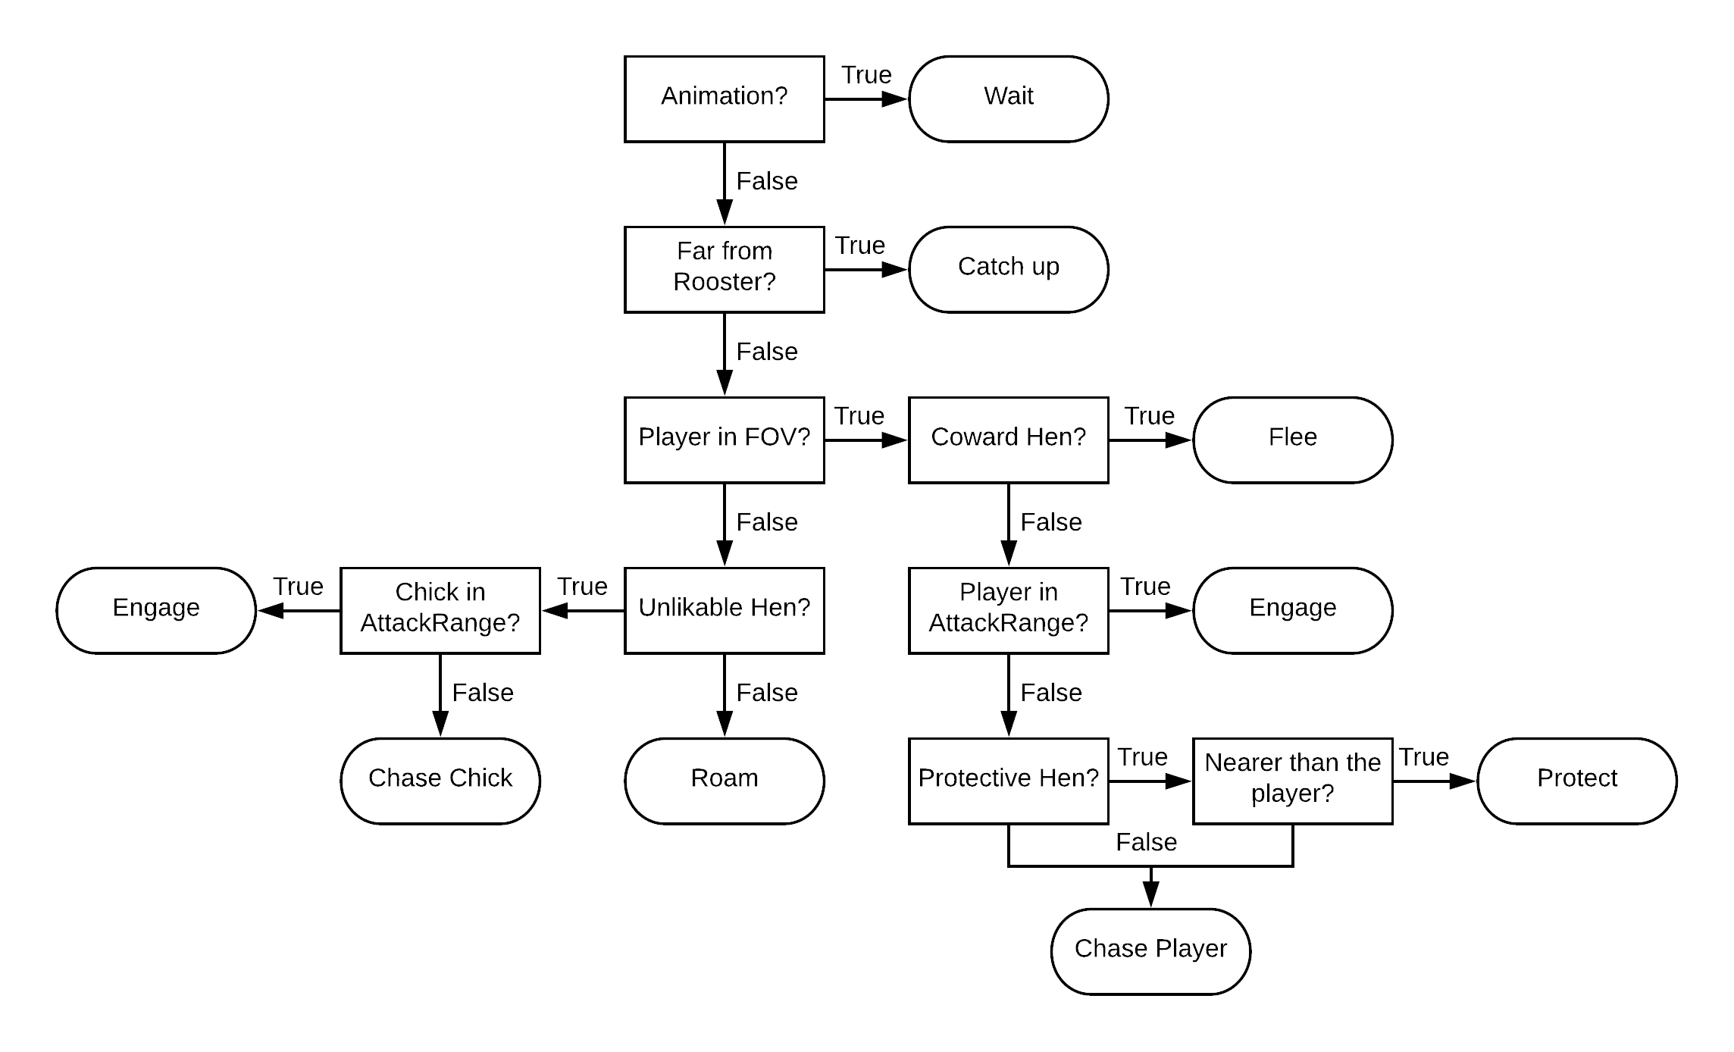

2.1 The single personalities are:
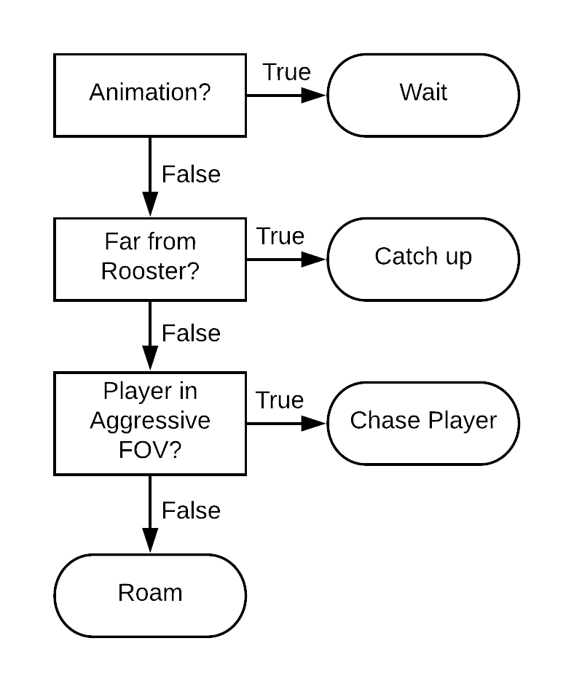 | Aggressive Hen: it has a longer range field of view and can detect the player from farther away than the rest of the hens, allowing them to spot easier the player.
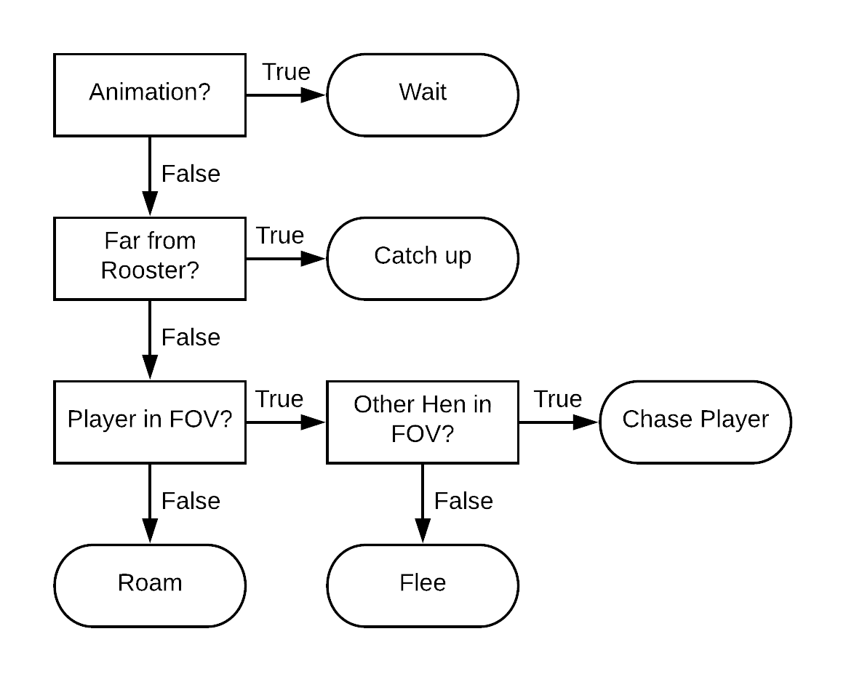 | Coward Hen: it is scared to approach the player alone, it will chase him only if it can find another hen nearby otherwise will flee and run away scared.
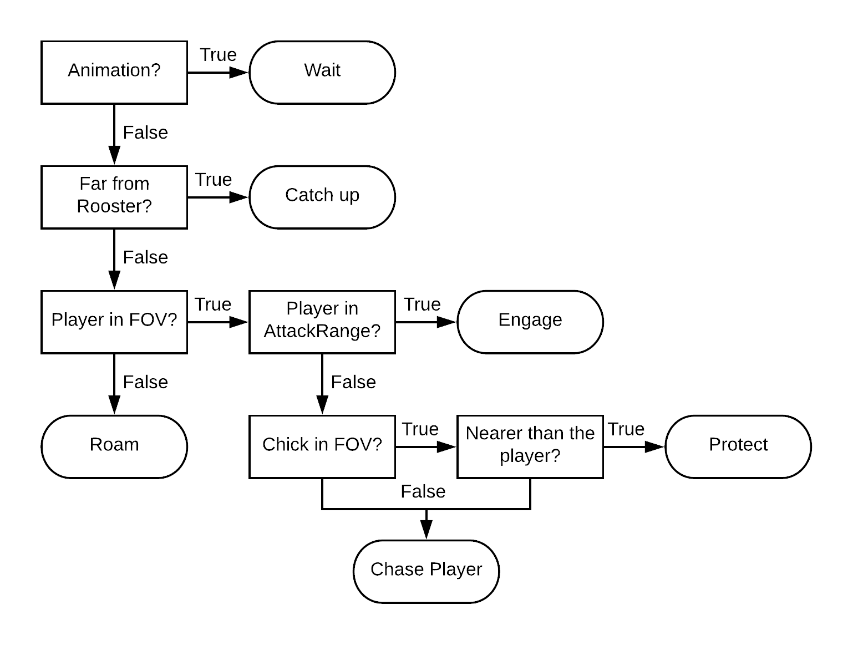 | Protective Hen: it is the most apprehensive hen and will try to protect the chicks from the player, getting in between them and the players who try to come close.
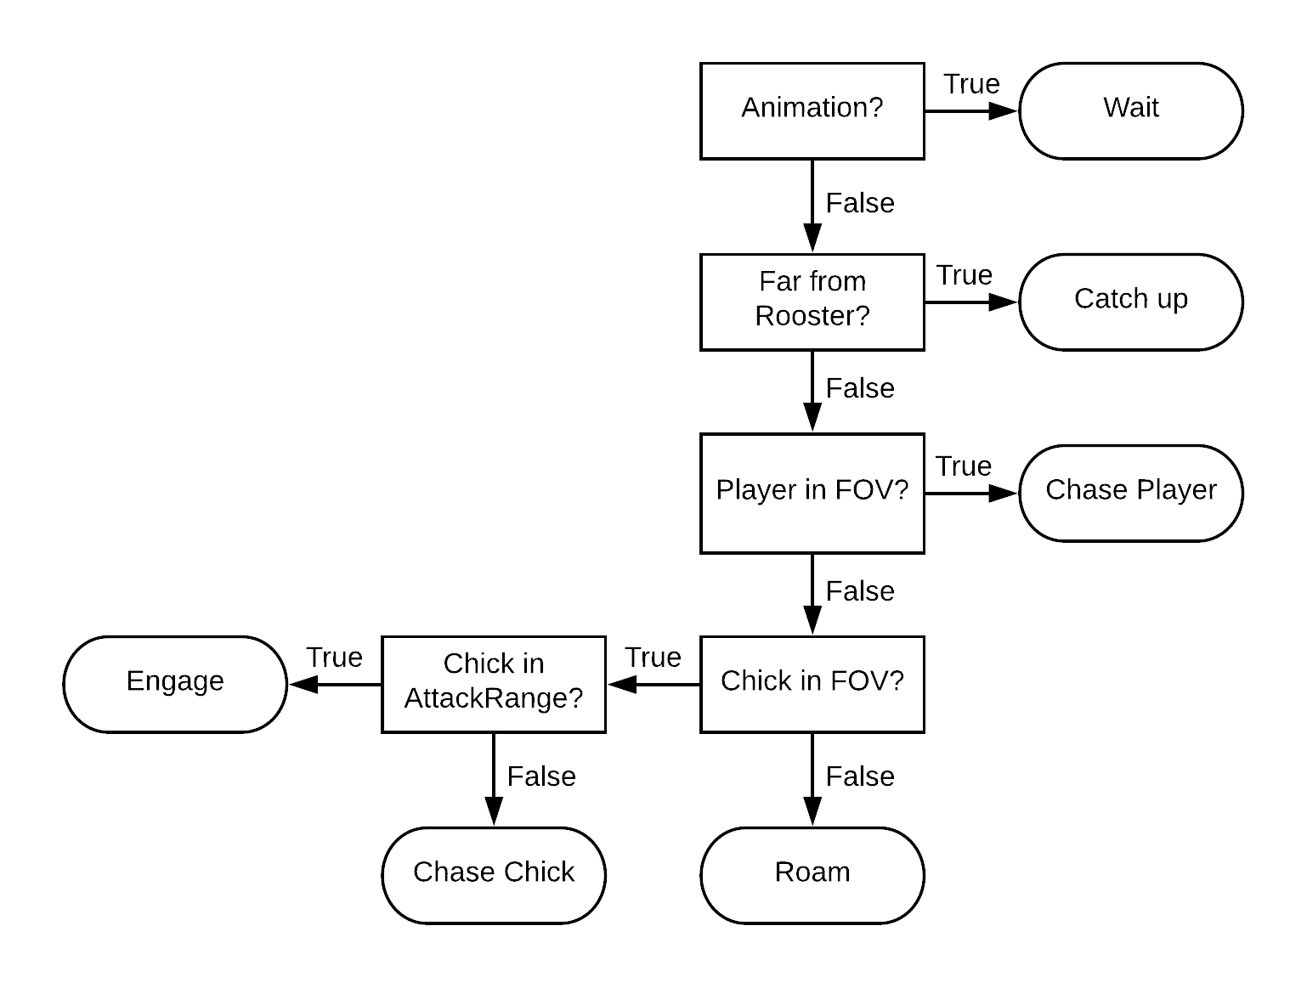 | Unlikable Hen: it can’t have chicks of its own so it hates everyone else’s and will chase and attack who ever gets too close, players or chicks.

3. Chick personalities

The chicks will call the rooster for help if a player gets too close.

The general behavior is: the chicks roam randomly if no player is in its field of view. It will then run away from them if in sight and if they manage to get close enough it will call the rooster for help.

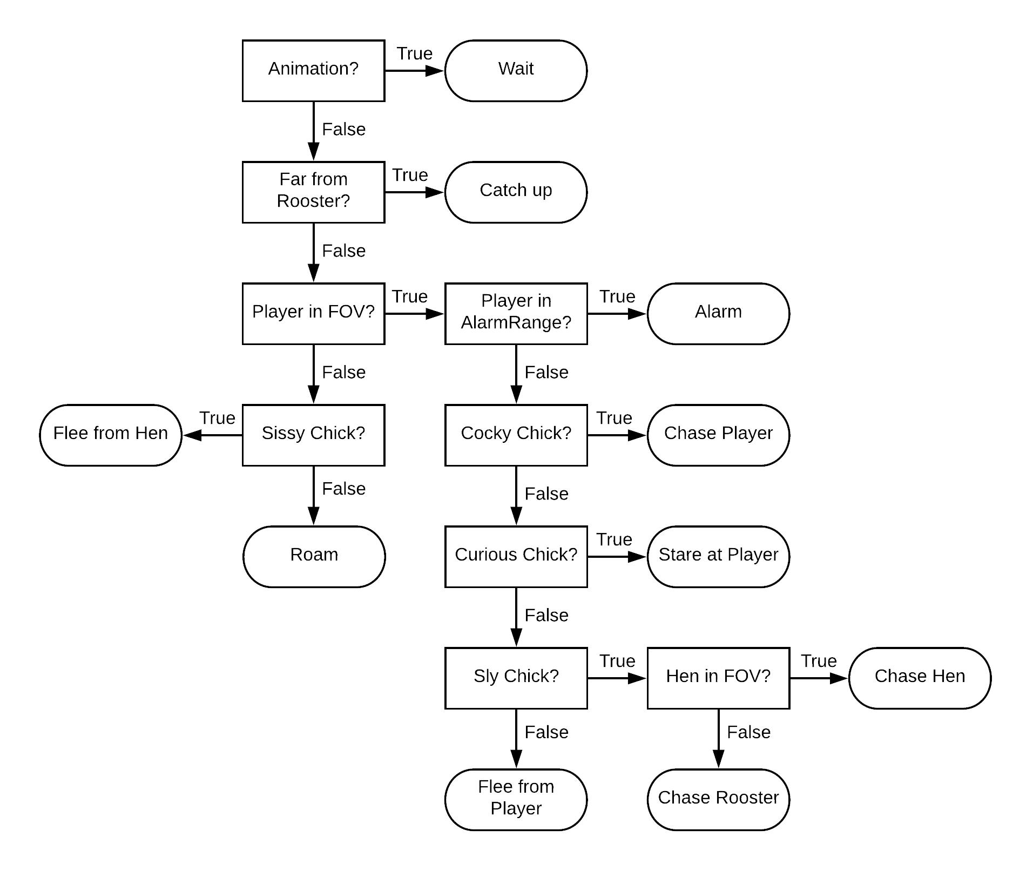

3.1 The single personalities are:
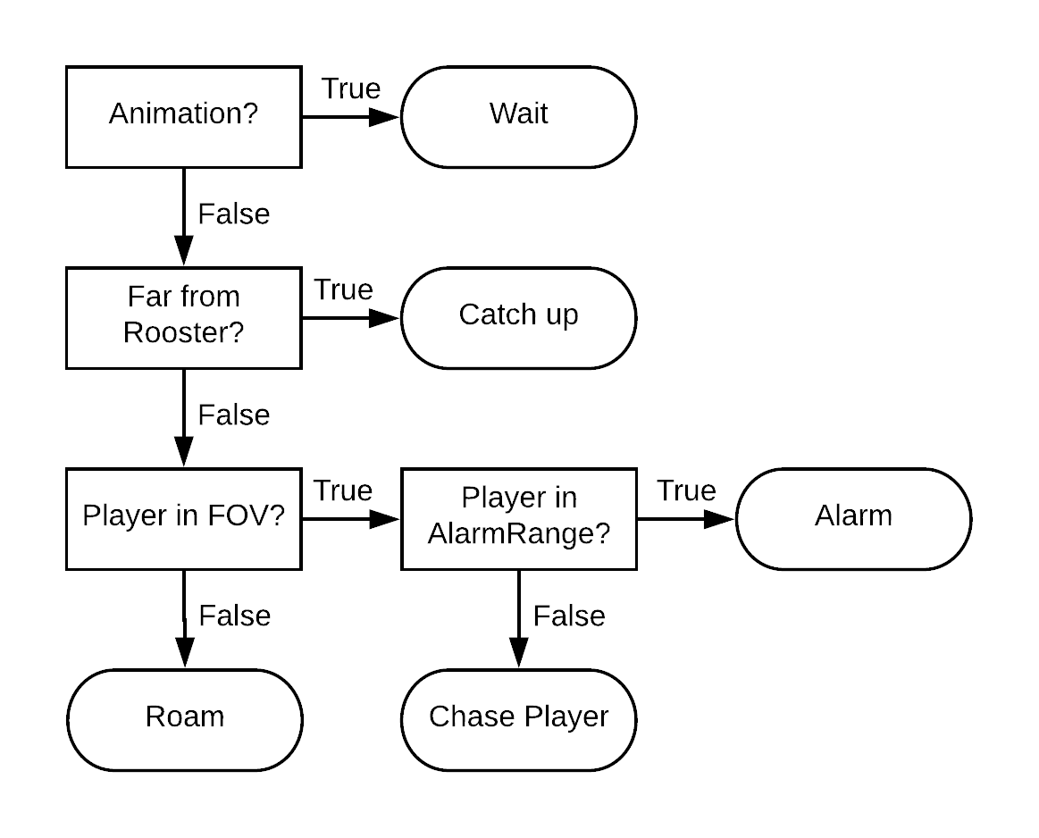 | Cocky Chick: it thinks to be able to manage the player on its own so it will chase him, but once it gets close enough it realizes that it needs to call for help.
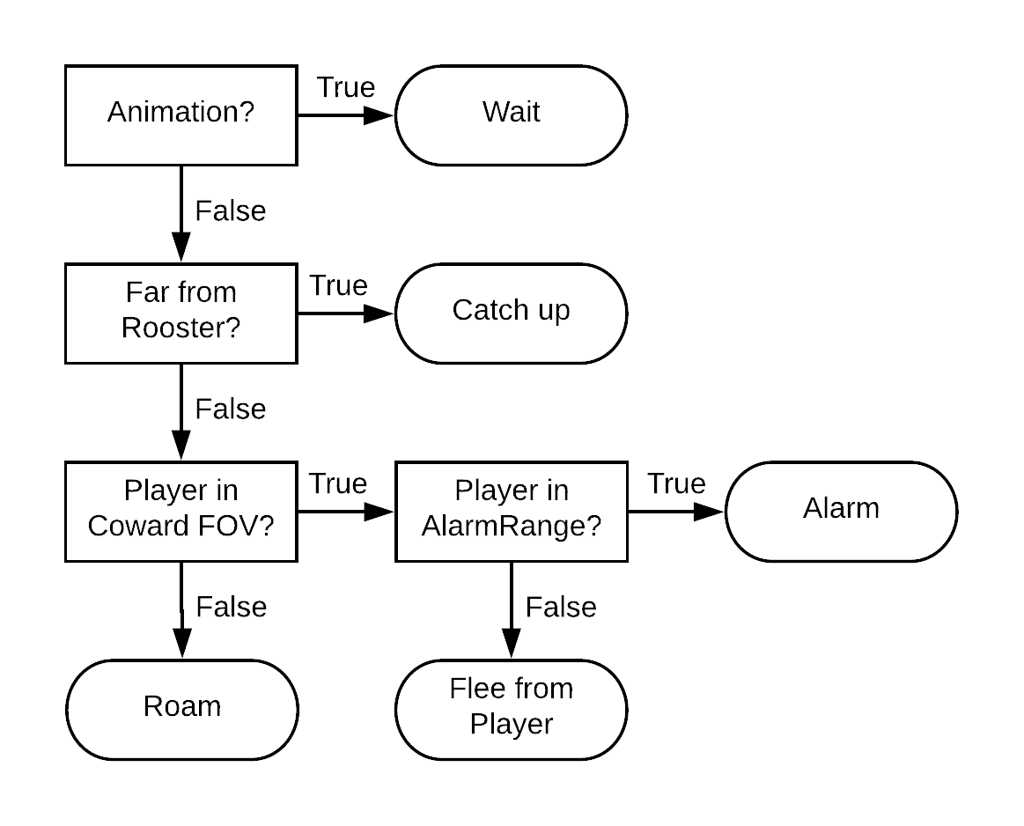 | Coward Chick: it has a longer range field of view and can detect the player from farther away than the rest of the chicks, allowing them to spot easier the player.
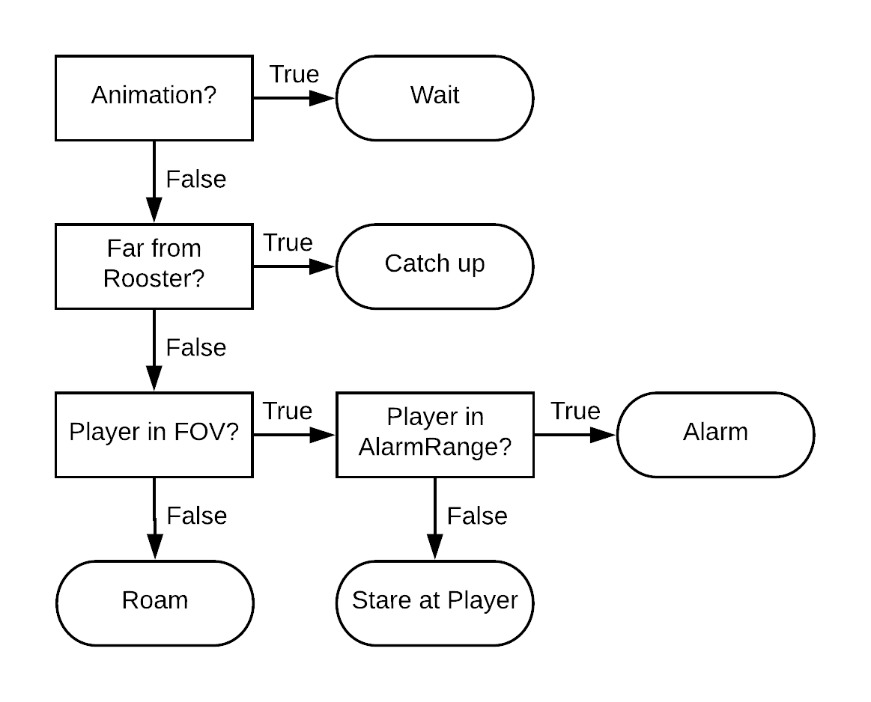 | Curious Chick: it is not afraid of the player, but rather interested. It doesn’t flee nor charge them, just stares at them not knowing what to do exactly.
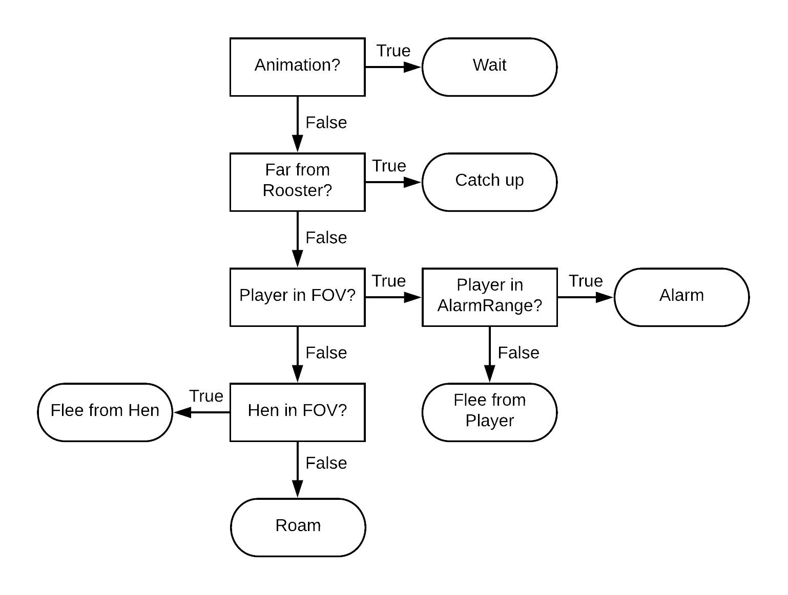 | Sissy Chick: it is scared of everything, both players and hens, if either of them gets close it will run away.
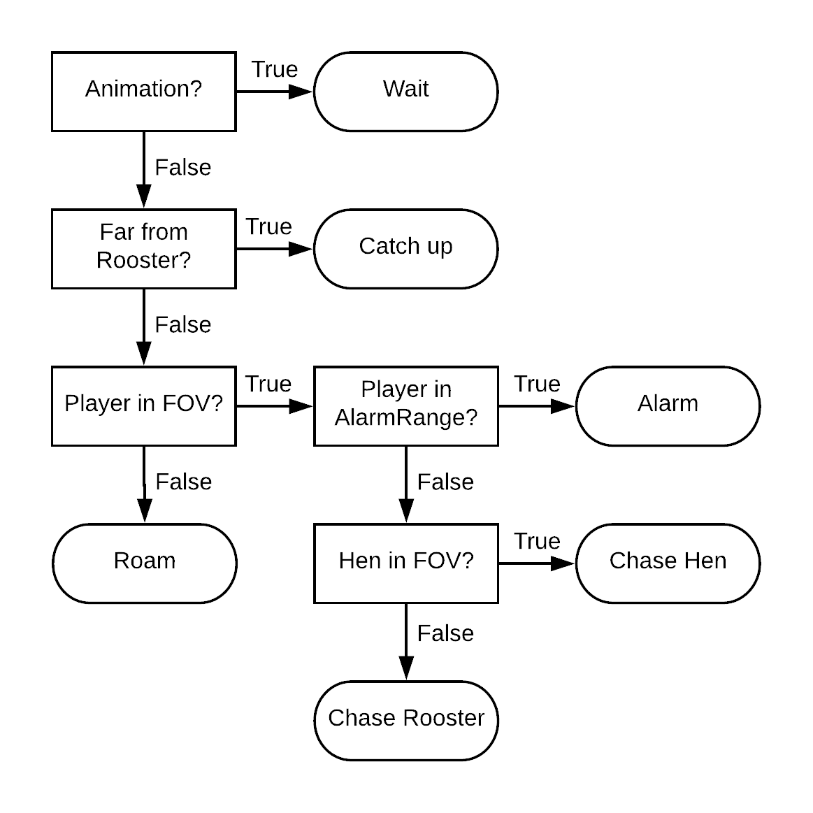 | Sly Chick: it is more cunning than the other chicks, if a player approaches it will look for nearby hens hoping for their help, otherwise it will go straight to the rooster.

4. The Rooster

The Rooster is the player’s main focus. It will chase the player as soon as he enters its field of view. As it is faster than players, they should organize and use the chicks to trigger the alarm and drop the Rooster’s aggro and to switch it between them. Once the rooster steps on the trap the players must stay beside him to remove one of its lifes, while the hens will try to push them away. If they manage to do it the rooster looses a life, otherwise any nearby player will. Regardless of that, after 5 seconds the Rooster pushes the players away and reset running towards one of the angles of the maze.

